LAB REPORT实验报告
Lab Title | Array of Pointers |  |  |  | Number | 07
Stud. Name | Jiang Yunxiang | Major | CST |  | Class
Student ID | 2022102330 |  | Date | 4/7
Lab description/objectives:
Apr 7, 2023, is Friday. The user enters a date (1-30 ) in April, and your program will output the corresponding day of the week. Use an array of pointers to store the names of the days of the week.
Source code:
（Paste the source code here）
#include <stdio.h>

int main()
{
char* arr[] = { "Fri", "Sat", "Sun", "Mon", "Tue", "Wed", "Thu", };
int date;
printf("Enter the date of today\n");
scanf("%d", &date);
while (1) {
int corresponding_day = date % 7;
if (date >= 1 && date < 31) {
printf("The corresponding day of the date is %s", *(arr + corresponding_day));
break;
}
else {
printf("The input is not valid, plz enter a valid number again!!\n");
scanf("%d", &date);
}
}

return 0;
}
Program outputs:
（Paste the screenshot of program output here）
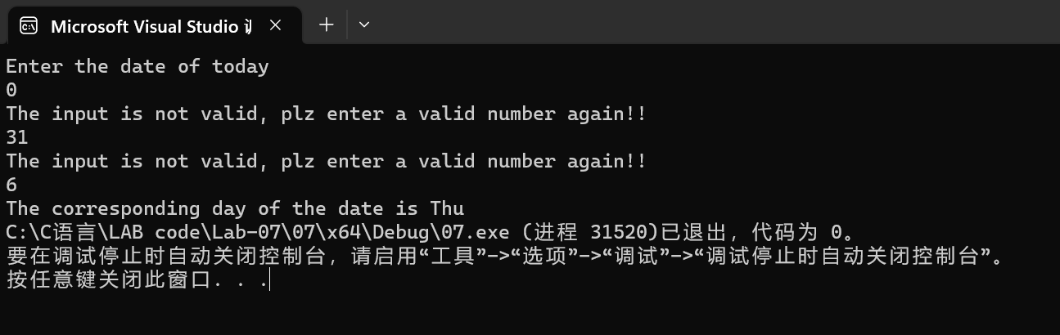
Discussion:
1．Most difficult parts
（What were the most difficult parts of your program to implement?）
Nope
2．Bugs and/or Errors
(List all the program bugs/errors you encountered and how you corrected them.)
Nope

